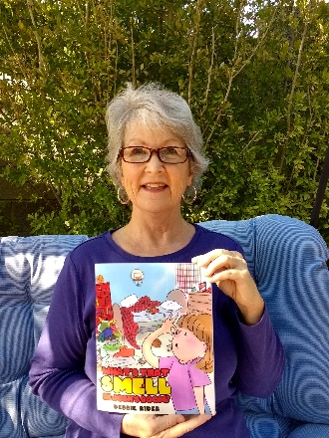
Children’s Author Debbie Rider is visiting our school!
Inspire lifelong readers with a personalized autographed book!
Dear Parents,
Children’s author Debbie Rider will be visiting ______________________School on_______________________. If you would like to purchase an autographed book by Debbie Rider, please return this order form along with your payment.
Order Due Date: __________________

Please make your check payable to Debbie Rider Author: Price $12.95 per book
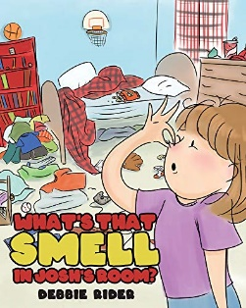What’s That Smell in Josh’s Room? Quantity _________________
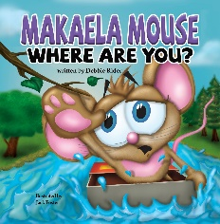Makaela Mouse Where Are You? Quantity_________________

Total Cost_______________________
Inscribe to:_______________________________________________
Teacher’s Name:__________________________________________
Grade Level:_____________________________________________

Books may also be purchased online at Amazon.com and barnesandnoble.com

